We’ve tested the program with 9 keywords, 11 describers for a person, 30 documents, and 17 rules. The program ranked the documents correctly, in the desired way, and took ~0.071 seconds to run.

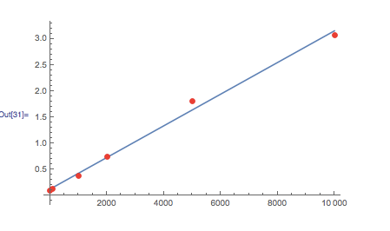

We ran a test case for 100 keywords, 50 describers for a person, 1000 documents, and ~400 rules. The program took ~0.38 seconds to run.